

Job Acceptance Prediction System

Leveraging Data Science and Machine Learning to Predict Job Acceptance



Project Type: Machine Learning – Binary Classification
Final Model: XGBoost Classifier
Application: Streamlit Web Application

ABSTRACT

The Job Acceptance Prediction System is a machine learning project developed in the domain of Human Resource Analytics.
Recruitment teams handle large volumes of candidate information, including academic qualifications, technical skills, professional experience, certifications, and interview performance. Analysing these attributes can help organizations understand candidate placement patterns and support recruitment-related decisions.
The objective of this project is to develop a binary classification model that predicts whether a candidate is placed or not placed based on candidate-related attributes.
The project uses Python libraries such as Pandas, NumPy, Scikit-learn, and XGBoost for data processing and machine learning. The dataset undergoes duplicate removal, data quality validation, missing-value handling, outlier analysis, and feature engineering.
Multiple machine learning models were evaluated as part of model development. XGBoost was selected as the final model.
The final model achieved:
- Accuracy: 91.79%
- Precision: 86.93%
- Recall: 85.76%
- F1-Score: 86.34%
- ROC-AUC: 97.62%
A Streamlit application was developed to accept candidate information and display the predicted placement status and class probability estimates.
The project demonstrates an end-to-end machine learning workflow, from raw data processing to an interactive prediction application.

CHAPTER 1 – INTRODUCTION

  - Introduction
Human Resource Analytics involves using data analysis and statistical techniques to support recruitment, employee management, and workforce planning.
Recruitment teams evaluate candidates based on multiple factors, including educational qualifications, technical knowledge, work experience, communication skills, certifications, and interview performance.
Analyzing these attributes can help organizations understand the characteristics associated with successful placement outcomes.
The Job Acceptance Prediction System applies machine learning techniques to candidate-related data to predict placement outcomes.
The project follows a complete data science workflow:
- Data collection
- Data understanding
- Data quality assessment
- Data cleaning and preprocessing
- Exploratory data analysis
- Feature engineering
- Machine learning model development
- Model evaluation
- Streamlit application development

  - Project Overview
The project uses an HR job placement dataset containing candidate academic, skill-based, experience-related, and interview-related information.
The target variable is status, which contains two classes:
- Placed
- Not Placed
A machine learning classification model is trained to identify patterns between candidate attributes and placement outcomes.
The trained model is integrated into an interactive Streamlit application.
1.3 Project Scope
The project focuses on:
- Understanding candidate-related data.
- Identifying and handling data quality issues.
- Exploring relationships between candidate attributes and placement outcomes.
- Creating meaningful features.
- Developing a classification model.
- Evaluating model performance.
- Providing an interactive prediction interface.

1.4 Importance of the Project
This project demonstrates how machine learning can support HR analytics by providing data-driven insights into candidate placement outcomes.
It can help recruitment teams organize candidate information and support structured candidate assessments.

CHAPTER 2 – PROBLEM STATEMENT AND OBJECTIVES

2.1 Problem Statement
Recruitment and placement teams handle large amounts of candidate information. Evaluating this information manually can be time-consuming.
Candidate placement outcomes may be associated with multiple factors, such as:
- Academic performance
- Technical skills
- Professional experience
- Certifications
- Interview performance
- Job role suitability
- Company-related factors
- Competition level
The objective is to develop a machine learning system that analyzes these attributes and predicts whether a candidate is placed or not placed.
2.2 Project Objectives
The primary objectives are:
- Analyze the HR job placement dataset.
- Identify missing values, duplicate records, and inconsistent data.
- Perform data cleaning and preprocessing.
- Conduct exploratory data analysis.
- Identify relationships between candidate attributes and placement status.
- Create meaningful engineered features.
- Develop supervised machine learning classification models.
- Compare model performance.
- Select and save the final model.
- Build an interactive Streamlit prediction application.
2.3 Business Use Cases
The system can support:
- Candidate placement analysis.
- Recruitment performance assessment.
- Identification of candidate attributes associated with placement.
- Data-driven recruitment planning.
- Structured candidate evaluation.
- Analysis of placement trends.
2.4 Target Variable
The target variable is:
Status
Target value | Description
Placed | Candidate has a placed outcome
Not Placed
  Candidate has a not-placed outcome

CHAPTER 3 – DATASET DESCRIPTION

3.1 Dataset Overview
The project uses the dataset:
HR_Job_Placement_Dataset.csv
The dataset contains candidate information related to academic performance, skills, experience, interview performance, and placement outcomes.
Description | Value
Original records | 51,500
Original columns | 26
Exact duplicate records identified | 1,376
Records after duplicate removal | 50,124
Final validated records | 50,000

3.3 Dataset Feature Categories
The dataset contains different types of candidate attributes.
A. Academic Features
These features represent the candidate's educational background and academic performance.
Examples include:
- SSC percentage
- HSC percentage
- Degree percentage
- Degree specialization
B. Experience Features
These features represent the candidate's professional experience.
Examples include:
- Years of experience
- Employment gap
- Previous employment-related information
C. Technical and Skill Features
These features represent the candidate's technical capabilities and suitability for a job role.
Examples include:
- Technical score
- Skills match percentage
- Certifications
- Internship experience
D. Interview and Assessment Features
These features represent candidate assessment performance.
Examples include:
- Aptitude score
- Communication score
- Interview-related performance
E. Recruitment and Job-Related Features
These features describe job suitability and recruitment conditions.
Examples include:
- Company tier
- Job role match
- Competition level
F. Target Feature
status represents the candidate's placement outcome.
3.4 Initial Data Understanding
The following checks were performed:
- Dataset dimensions using df.shape.
- Sample records using df.head().
- Column information using df.info().
- Statistical summaries using df.describe().
- Missing-value counts.
- Duplicate-record counts.
- Unique-value analysis.
- Data type validation.

CHAPTER 4 – DATA CLEANING AND PREPROCESSING
4.1 Introduction
Data cleaning is an important stage of machine learning because incomplete, inconsistent, or duplicated data can affect model performance.
The project uses a modular data cleaning pipeline to process the original dataset.
4.2 Duplicate Removal
The initial dataset contained 51,500 records.
Exact duplicate records were identified and removed.
Description | Records
Original dataset | 51, 500
Duplicate records removed | 1376
Records after removal | 50, 124

Duplicate removal helps avoid repeated records influencing the analysis and model training.
4.3 Data Quality Assessment
The dataset was examined for:
- Missing values.
- Duplicate records.
- Invalid numerical values.
- Inconsistent categorical values.
- Incorrect data types.
- Business-rule violations.
These checks helped identify data issues before preprocessing.
4.4 Missing Value Analysis
Missing values were examined separately for numerical and categorical features.
The analysis included:
- Missing-value count.
- Missing-value percentage.
- Mean and median.
- Skewness.
- Distribution analysis.
- Potential outlier influence.
Examples of numerical columns with missing values included:
- ssc_percentage
- hsc_percentage
Missing-value indicators were created to preserve information about whether selected values were originally missing.
4.5 Missing Value Handling
Different imputation strategies were selected according to feature characteristics.
Numerical Features
- Mean imputation was used for selected numerical features.
- Median imputation was used for selected numerical features.
Categorical Features
- Appropriate categorical replacement strategies were applied.
- Optional missing categorical values were represented using Unknown where required.
Missing Indicators
Binary indicator features were created to capture original missingness.
This allows the model to learn whether the absence of a value may contain useful information.
4.6 Business Validation
Business validation rules were applied to check logical consistency across candidate attributes.
The cleaned data was validated after missing-value handling.
The final validated dataset contained:
- 50,000 records.
- 35 columns.
- No remaining missing values.
4.7 Outlier Analysis
The Interquartile Range (IQR) method was used to identify potential outliers in numerical features.
The IQR is calculated as:
IQR = Q3 − Q1
The lower and upper boundaries are:
Lower Boundary = Q1 − 1.5 × IQR
Upper Boundary = Q3 + 1.5 × IQR
Potential outliers were identified in numerical features.
Based on the project decision, the identified outliers were retained without treatment.
This avoided removing potentially valid candidate observations without sufficient business evidence.
4.8 Final Data Validation
The final cleaned dataset was checked for:
- Missing values.
- Duplicate records.
- Valid data types.
- Logical consistency.
- Numerical ranges.
- Target variable consistency.
total_rows | total_columns
50000 | 40

CHAPTER 5 – EXPLORATORY DATA ANALYSIS

5.1 Introduction
Exploratory Data Analysis (EDA) is used to understand the structure, distribution, and relationships within the dataset.
EDA was performed before model development to understand candidate characteristics and placement-related patterns.
5.2 Dataset Overview
The dataset overview analysis includes:
- Total records.
- Total features.
- Numerical feature count.
- Categorical feature count.
- Missing-value summary.
- Duplicate summary.
- Data type distribution.
5.3 Data Quality Analysis
The data quality analysis examined:
- Missing-value distribution.
- Duplicate records.
- Invalid values.
- Numerical outliers.
- Categorical inconsistencies.
The purpose was to establish the reliability of the dataset before conducting further analysis.
5.4 Target Variable Analysis
The target variable status was examined to understand the distribution of:
- Placed candidates.
- Not-placed candidates.
The target distribution should be represented using a count plot or bar chart.
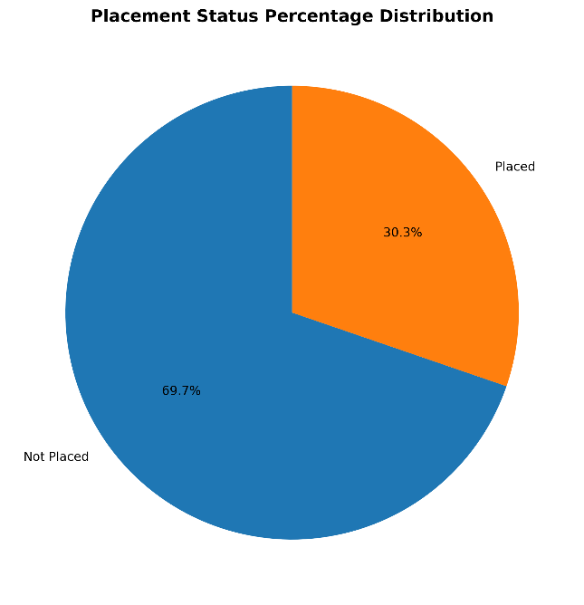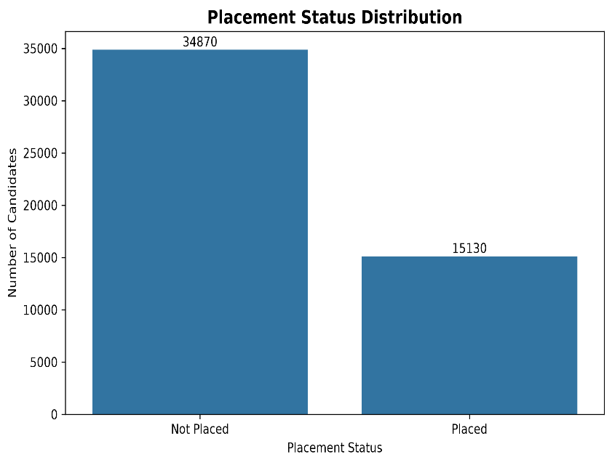
5.5 Numerical Feature Analysis
Numerical features were examined using:
- Descriptive statistics.
- Histograms.
- Box plots.
- Distribution plots.
- Correlation analysis.
Important numerical features include:
- Academic percentages.
- Years of experience.
- Technical score.
- Aptitude score.
- Communication score.
- Skills match percentage.
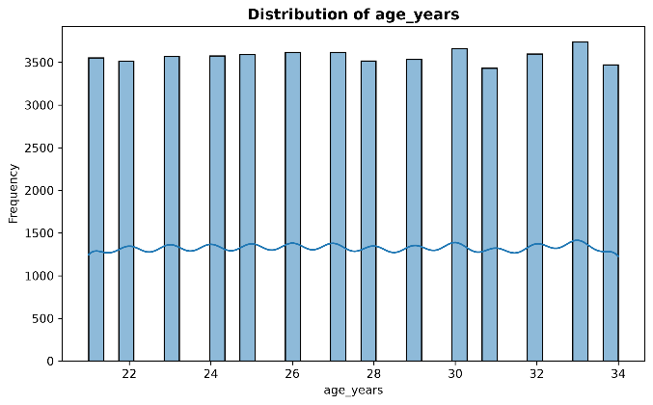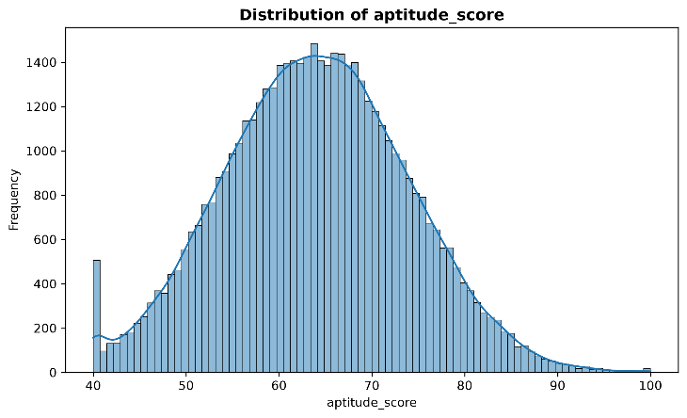
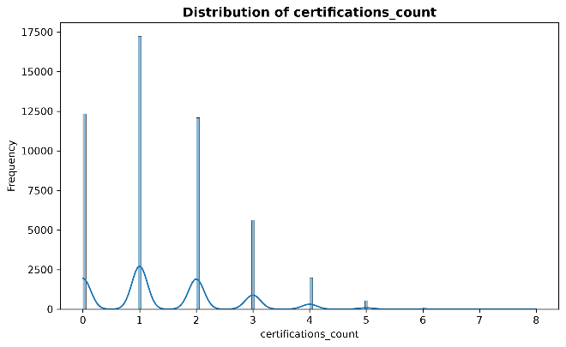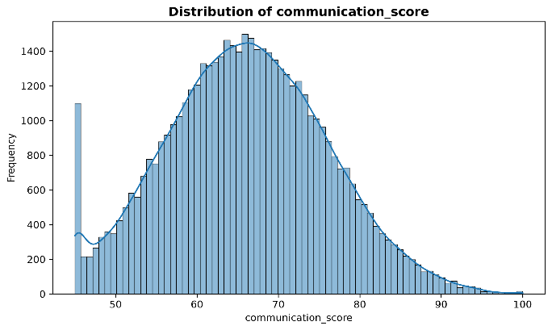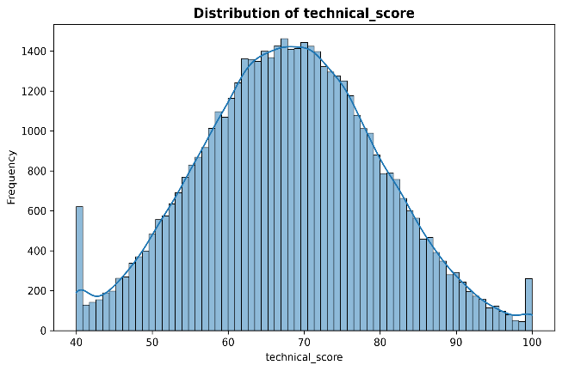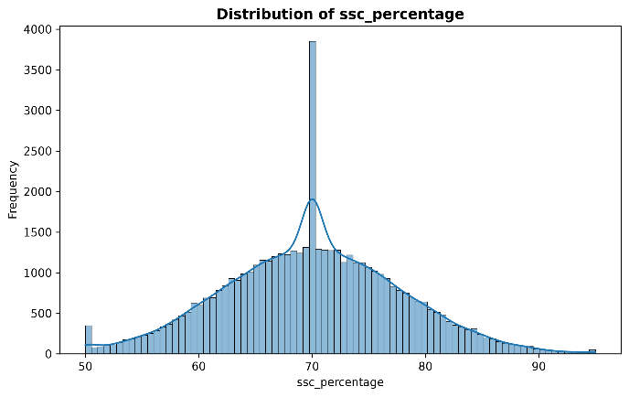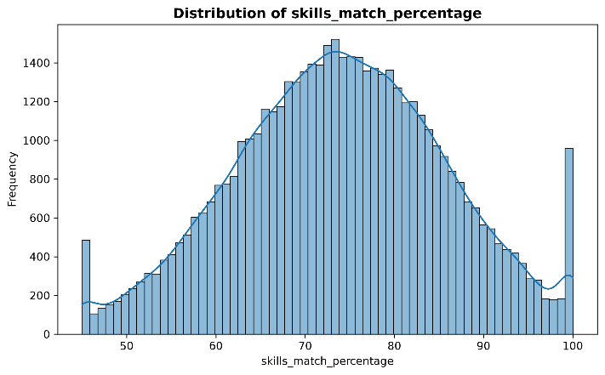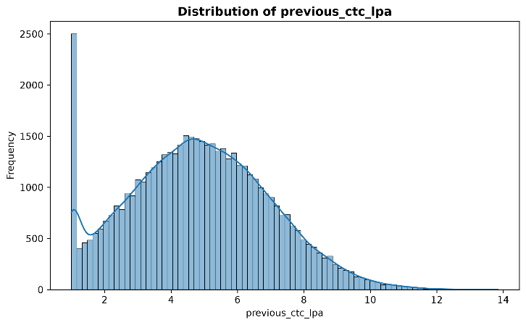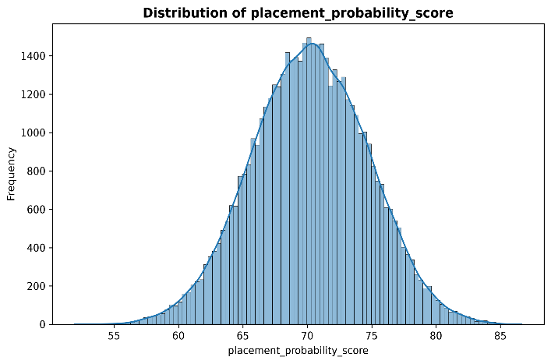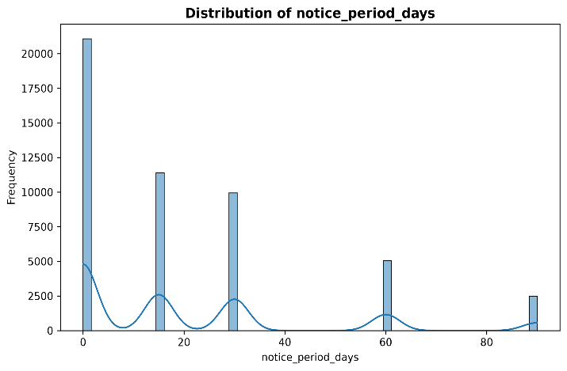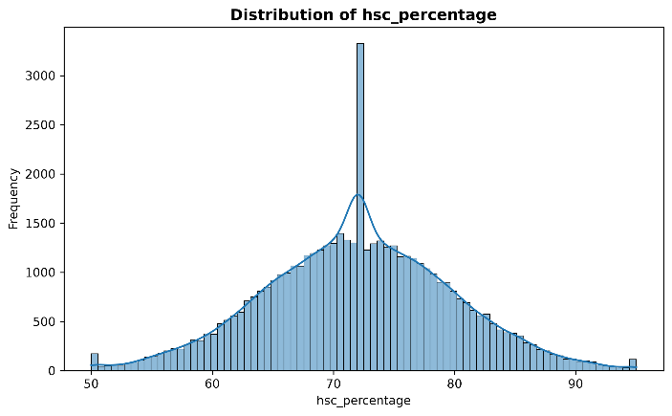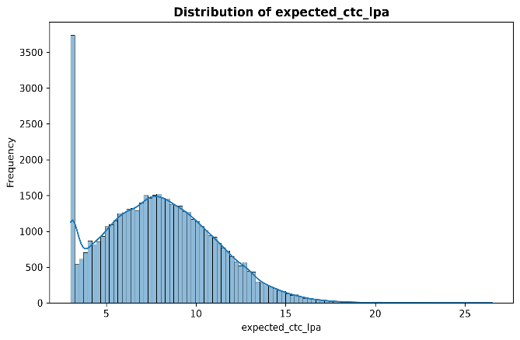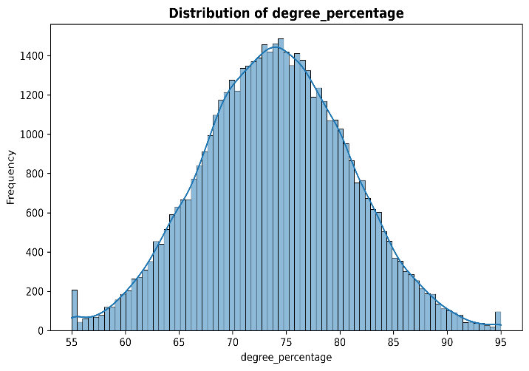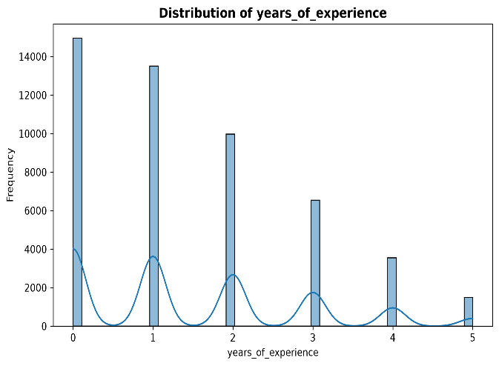

5.6 Categorical Feature Analysis
Categorical features were examined using frequency distributions and count plots.
The analysis focused on features such as:
- Degree specialization.
- Gender.
- Company tier.
- Job role match.
- Internship experience.
- Competition level.

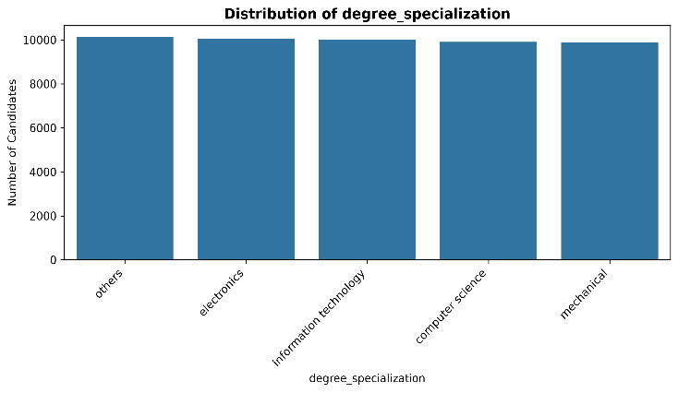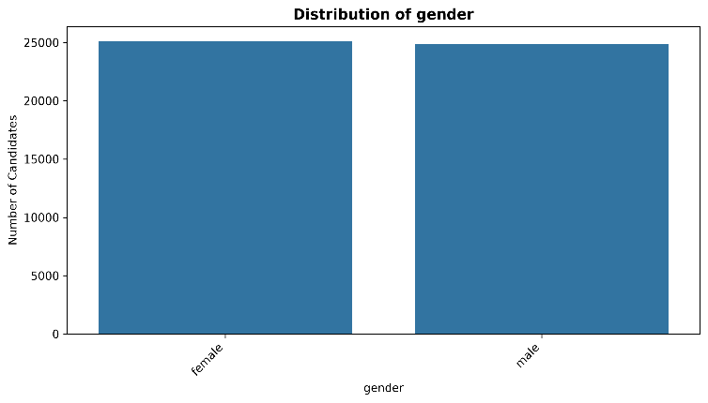
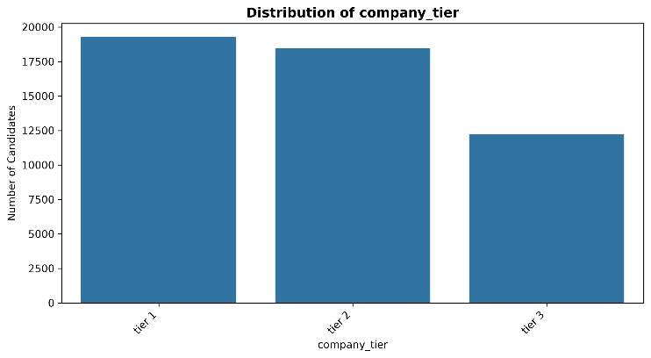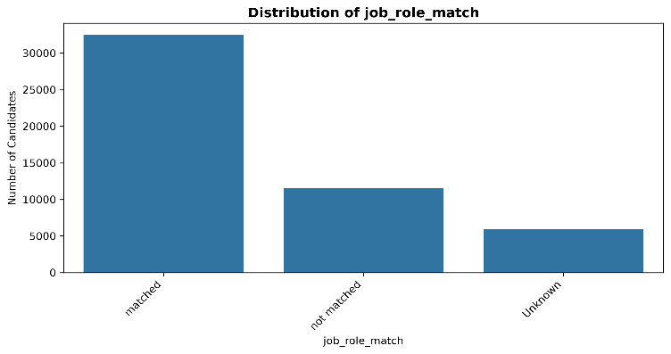
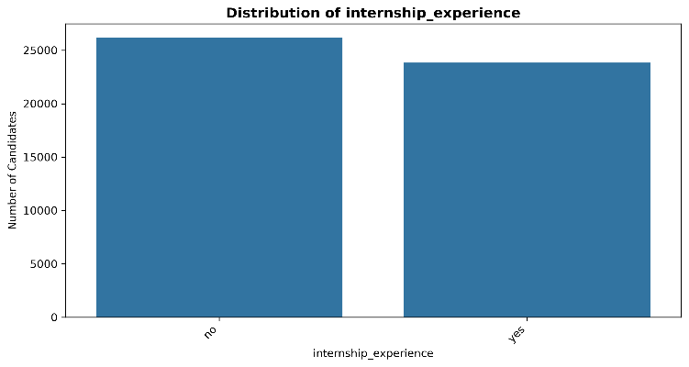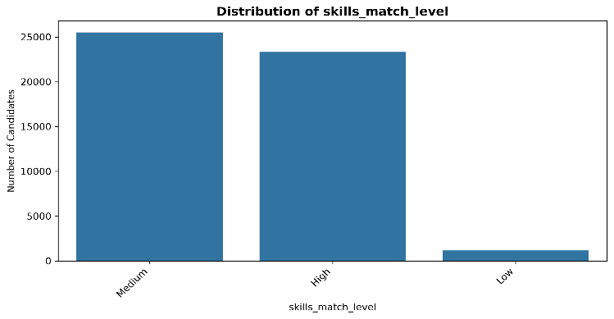

5.7 Bivariate Analysis
Bivariate analysis examines the relationship between two variables.
The project brief identifies the following useful analytical comparisons:
- Interview performance versus placement status.
- Skills match percentage versus placement status.
- Company tier versus placement outcomes.
- Experience versus placement outcomes.
- Competition level versus placement status.
- Academic performance versus placement outcomes.
These analyses can help identify relationships between candidate characteristics and placement outcomes.
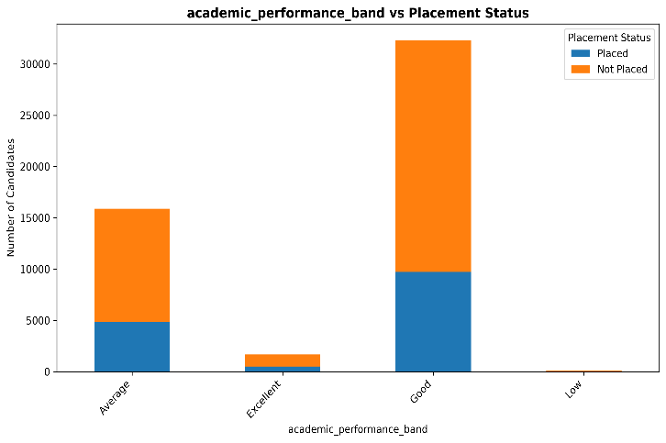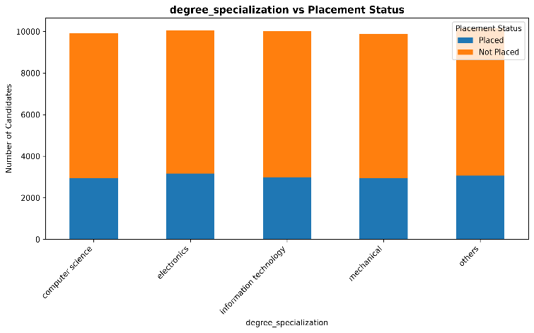
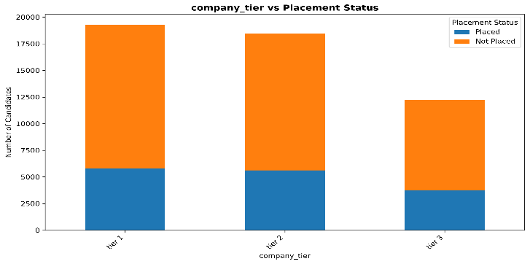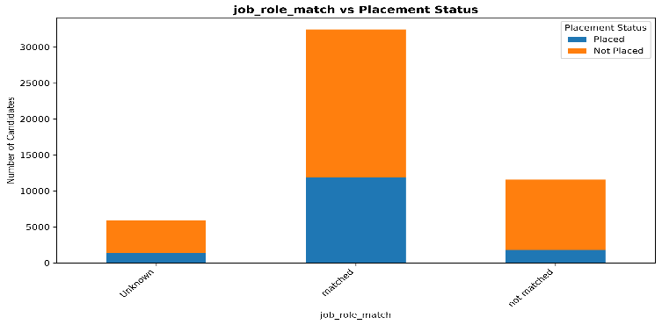
5.8 Correlation Analysis
Correlation analysis was used to examine relationships between numerical features.
A correlation matrix can help identify:
- Positively correlated features.
- Negatively correlated features.
- Weak relationships.
- Potential multicollinearity.
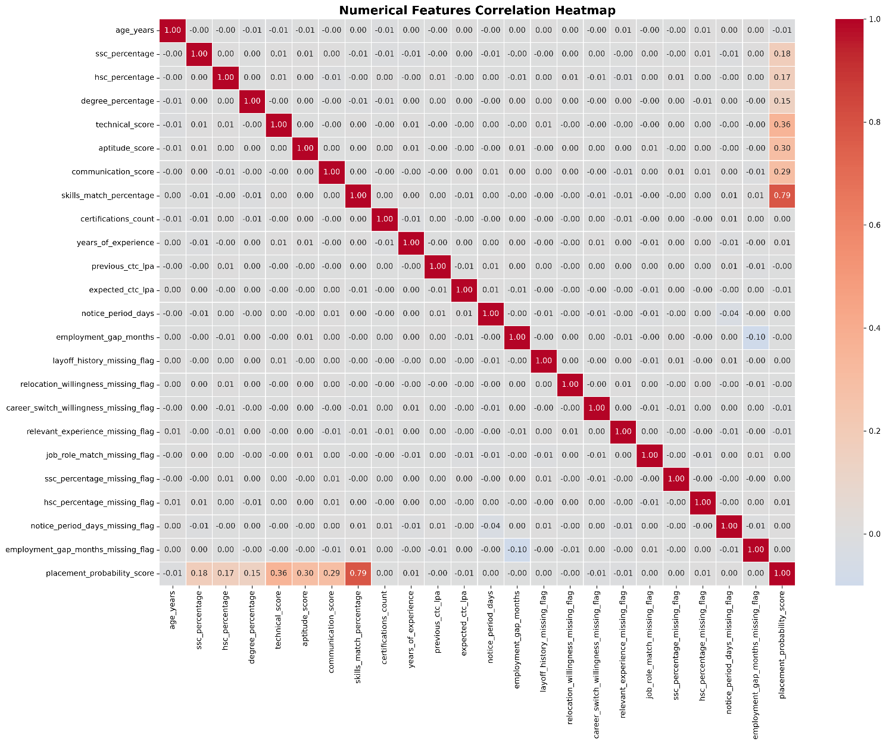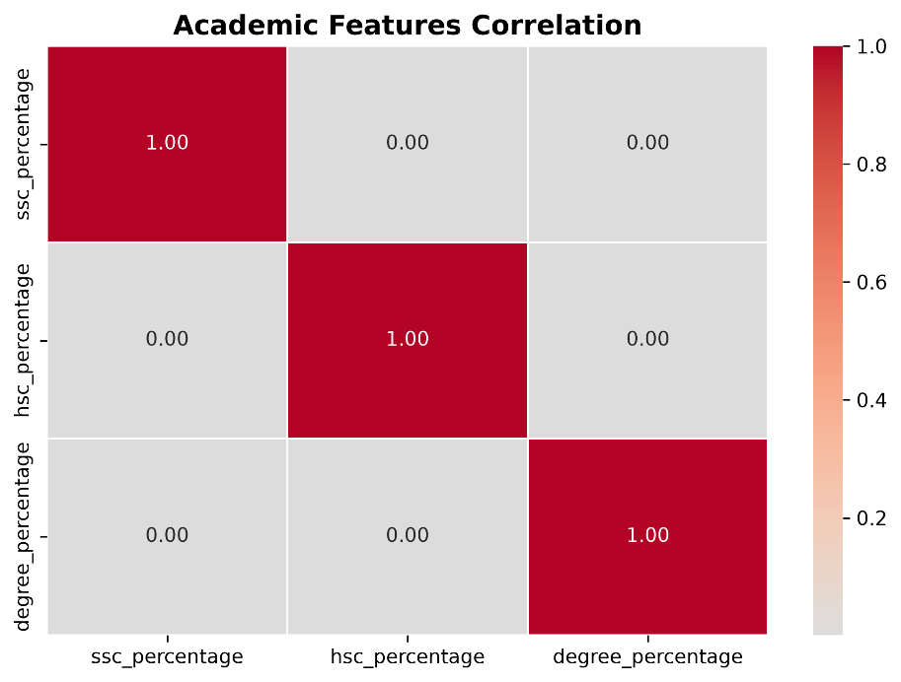

CHAPTER 6 – FEATURE ENGINEERING
6.1 Introduction
Feature engineering is the process of creating meaningful variables from existing dataset attributes.
It helps convert raw candidate information into more useful representations for machine learning.
The project created four engineered categorical features for model training and also calculated a placement probability score for analytical purposes.
6.2 Experience Category
The numerical feature years_of_experience was converted into three categories.
Experience | Category
0 years | Fresher
Above 0 to 3 years | Junior
Above 3 years | Senior

This feature provides a simplified representation of professional experience.
6.3 Academic Performance Band
The average of the following academic features was calculated:
- SSC percentage.
- HSC percentage.
- Degree percentage.
The average academic score was converted into performance bands.
Average academic score | Category
Below 60 | Low
60 to below 70 | Average
70 to below 80 | Good
80 and above | Excellent

6.4 Skills Match Level
The feature skills_match_percentage was converted into three categories.
Skills match percentage | Category
Below 50 | Low
50 to below 75 | Medium
75 and above | High

This feature represents how closely the candidate's skills match the job requirements.
6.5 Interview Performance Category
Interview performance was converted into a categorical feature based on the project's implemented thresholds.
The final category represents the candidate's interview performance.
Insert the exact threshold values from the feature engineering script before final submission.
6.6 Placement Probability Score
A placement probability score was calculated as an analytical feature in the data preparation workflow.
However, this score was excluded from the model input features to avoid target leakage.
6.7 Missing-Value Indicators
Missing indicators were retained as model features.
They capture whether selected original candidate attributes were missing before imputation.
6.8 Final Feature Set
The model uses 38 input features.
Feature group | Number of features
Numerical features | 14
Categorical features | 11
Missing-value indicators | 9
Engineered categorical features | 4
Total | 38

The feature groups are maintained in the model configuration to ensure consistent feature order during training and prediction.

CHAPTER 7 – MACHINE LEARNING METHODOLOGY

7.1 Introduction
The project uses supervised machine learning to predict candidate placement outcomes.
Since the target variable contains two classes, the task is treated as a binary classification problem.
7.2 Target Variable
The target variable is:
status
The two target classes are:
- Placed
- Not Placed
The model learns relationships between candidate input features and the target variable.
7.3 Train-Test Split
The cleaned dataset was divided into training and testing datasets.
A stratified split was used to maintain the target class distribution.
Dataset | Records | Percentage
Training data | 40,000 | 80%
Testing data | 10,000 | 20%
Total | 50,000 | 100%

Random state: 42
7.4 Data Preprocessing Pipeline
The preprocessing pipeline was developed using Scikit-learn.
Numerical Features
Numerical features were processed using:
- Median imputation.
- StandardScaler.
StandardScaler transforms numerical values based on their mean and standard deviation.
Categorical Features
Categorical features were processed using:
- Most-frequent imputation.
- OneHotEncoder.
The encoder uses:
handle_unknown="ignore"
This allows the pipeline to handle previously unseen categories during prediction.
Missing Indicators
Binary missing-value indicator features were processed using the configured most-frequent imputation strategy.
7.5 Prevention of Data Leakage
The preprocessing pipeline was fitted using training data only.
The testing data was transformed using the already-fitted pipeline.
The same principle is followed during application prediction:
- Load the saved preprocessing pipeline.
- Transform new candidate data.
- Do not fit or retrain the pipeline on the candidate input.
The placement probability score was also excluded from the model input features to avoid target leakage.
7.6 Model Development
Multiple classification models were evaluated during the machine learning stage.
The project uses a model comparison workflow based on common classification metrics.
The final selected model is XGBoost Classifier.
7.7 XGBoost Classifier
XGBoost is a gradient boosting algorithm that builds an ensemble of decision trees.
Each new tree helps improve the model by learning from errors made by previous trees.
XGBoost is useful for structured tabular datasets and can model nonlinear relationships between candidate attributes.

7.8 Model Saving
The final model and preprocessing pipeline were saved separately.
File | Purpose
final_model.pkl | Stores the trained XGBoost model
final_preprocessing_pipeline.pkl | Stores the fitted preprocessing pipeline
These artifacts are loaded by the Streamlit application for prediction.

CHAPTER 8 – MODEL EVALUATION AND COMPARISON

8.1 Introduction
Model evaluation is used to measure how well the trained classifier predicts placement outcomes on unseen test data.
The final model was evaluated using the 10,000-record test dataset.
8.2 Evaluation Metrics
The following metrics were used:
- Accuracy
- Precision
- Recall
- F1-Score
- ROC-AUC
8.3 Accuracy
Accuracy measures the percentage of correctly predicted records.
Accuracy = (Correct Predictions / Total Predictions)
The final model achieved:
91.79% accuracy
This indicates that approximately 91.79% of the test records were classified correctly.
8.4 Precision
Precision measures how many candidates predicted as placed actually belonged to the placed class.
Precision = TP / (TP + FP)
The final model achieved:
86.93% precision
8.5 Recall
Recall measures how many actual placed candidates were correctly identified by the model.
Recall = TP / (TP + FN)
The final model achieved:
85.76% recall
8.6 F1-Score
F1-Score is the harmonic mean of precision and recall.
F1-Score = 2 × (Precision × Recall) / (Precision + Recall)
The final model achieved:
86.34% F1-Score
8.7 ROC-AUC
ROC-AUC measures the model's ability to distinguish between the two target classes across classification thresholds.
The final model achieved:
97.62% ROC-AUC
8.8 Final Model Performance Summary
Metric | Final XGBoost Score
Accuracy | 91.79%
Precision | 86.93%
Recall | 85.76%
F1-Score | 86.34%
ROC-AUC | 97.62%

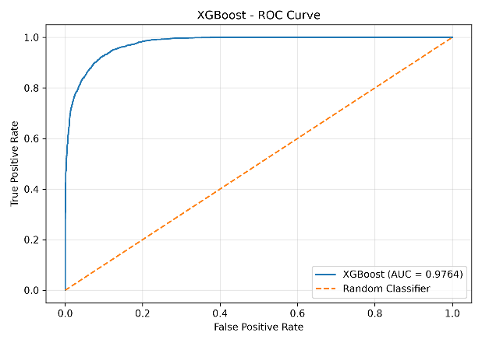
8.9 Model Comparison
Multiple classification models were evaluated during the project.
The final model selected for application deployment was XGBoost.
Model | Accuracy | Precision | Recall | F1-Score | ROC-AUC
XGBoost | 90.25% | 78.18% | 94.02% | 85.37% | 97.64%
Gradient Boosting | 88.45% | 74.39% | 94.28% | 83.17% | 97.00%
Logistic Regression | 86.75% | 73.31% | 88.40% | 80.15% | 94.79%
Random Forest | 86.06% | 71.38% | 90.02% | 79.63% | 95.29%
AdaBoost | 55.27% | 40.35% | 99.93% | 57.49% | 82.81%
Decision Tree | 81.06% | 63.92% | 85.89% | 73.29% | 90.99%

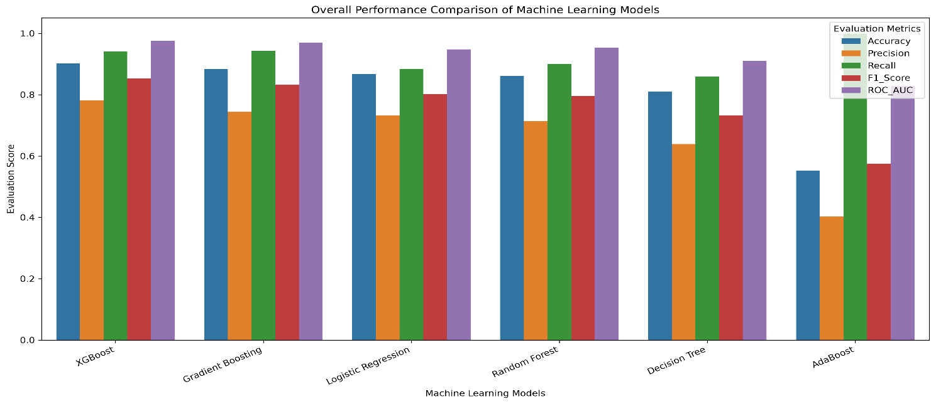
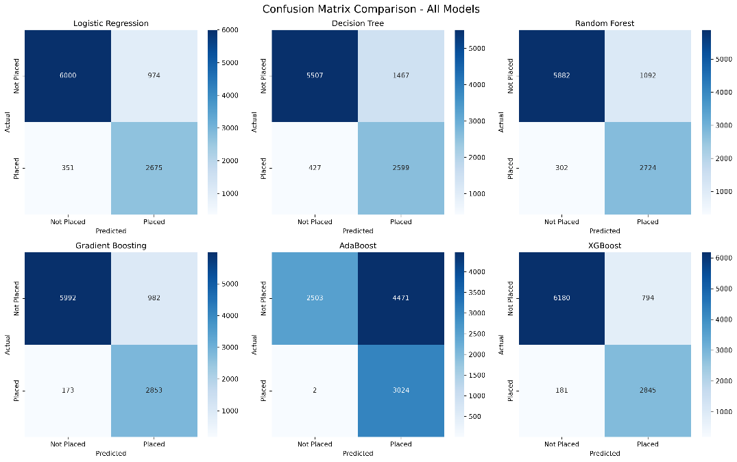
8.10 Confusion Matrix
A confusion matrix evaluates the classification results by comparing actual and predicted classes.
It contains:
- True Positive (TP)
- True Negative (TN)
- False Positive (FP)
- False Negative (FN)
For this project:
- True Positive: Actual placed candidate predicted as placed.
- True Negative: Actual not-placed candidate predicted as not placed.
- False Positive: Actual not-placed candidate predicted as placed.
- False Negative: Actual placed candidate predicted as not placed.

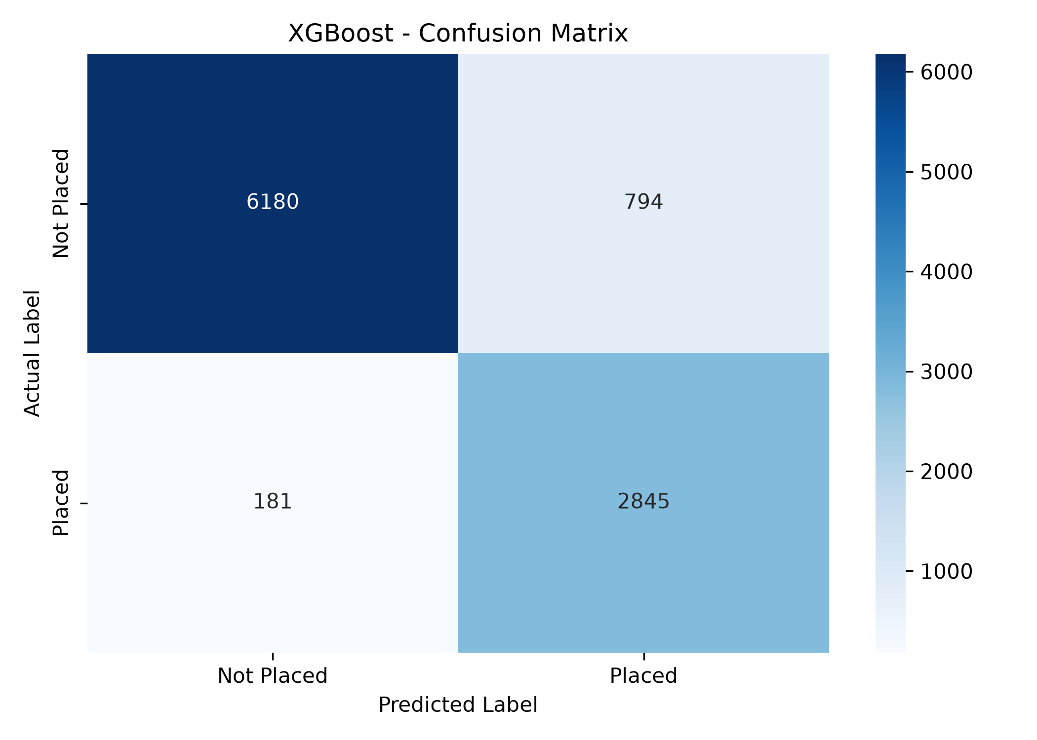

CHAPTER 9 – STREAMLIT APPLICATION DEVELOPMENT

9.1 Introduction
A Streamlit application was developed to make the trained machine learning model accessible through a web-based interface.
The application allows users to enter candidate information and receive placement predictions.
9.2 Application Features
The application includes:
- Candidate information input form.
- Numerical and categorical input fields.
- Candidate feature engineering.
- Saved model loading.
- Saved preprocessing pipeline loading.
- Placement prediction.
- Class probability estimates.
- Interactive Plotly chart.
- Candidate profile summary.
- Model processing information.
9.3 Application Architecture
The application follows a modular architecture.
Main Application
app.py
This file controls the Streamlit application and coordinates the different modules.
Configuration Module
app/config.py
Stores:
- Project paths.
- Model paths.
- Feature definitions.
- Target labels.
- Application configuration.
Input Form Module
app/input_form.py
Collects candidate information through Streamlit input components.
Feature Engineering Module
app/feature_engineering.py
Processes candidate inputs and generates the required model features.
Prediction Module
app/prediction.py
Loads the saved model and preprocessing pipeline, transforms the candidate features, and generates predictions.
Result Display Module
app/display_results.py
Displays:
- Predicted placement status.
- Class probabilities.
- Probability progress bars.
- Plotly chart.
- Candidate profile summary.
9.4 Prediction Workflow
The prediction workflow is:
- User enters candidate information.
- The application validates and collects the input.
- Feature engineering generates the 38 required model input features.
- The saved preprocessing pipeline transforms the features.
- The transformed data contains 68 processed features.
- The trained XGBoost model generates a prediction.
- Class probabilities are calculated.
- The result is displayed in the Streamlit dashboard.

9.5 Dashboard Output
The dashboard displays:
- Predicted outcome: Placed or Not Placed.
- Probability of being placed.
- Probability of not being placed.
- Interactive probability comparison chart.
- Candidate profile.
- Processing summary.
The probability values are model estimates and should not be interpreted as guaranteed real-world placement probabilities.
9.6 Running the Application
The application can be started using:
streamlit run app.py
The Streamlit application opens in a web browser.
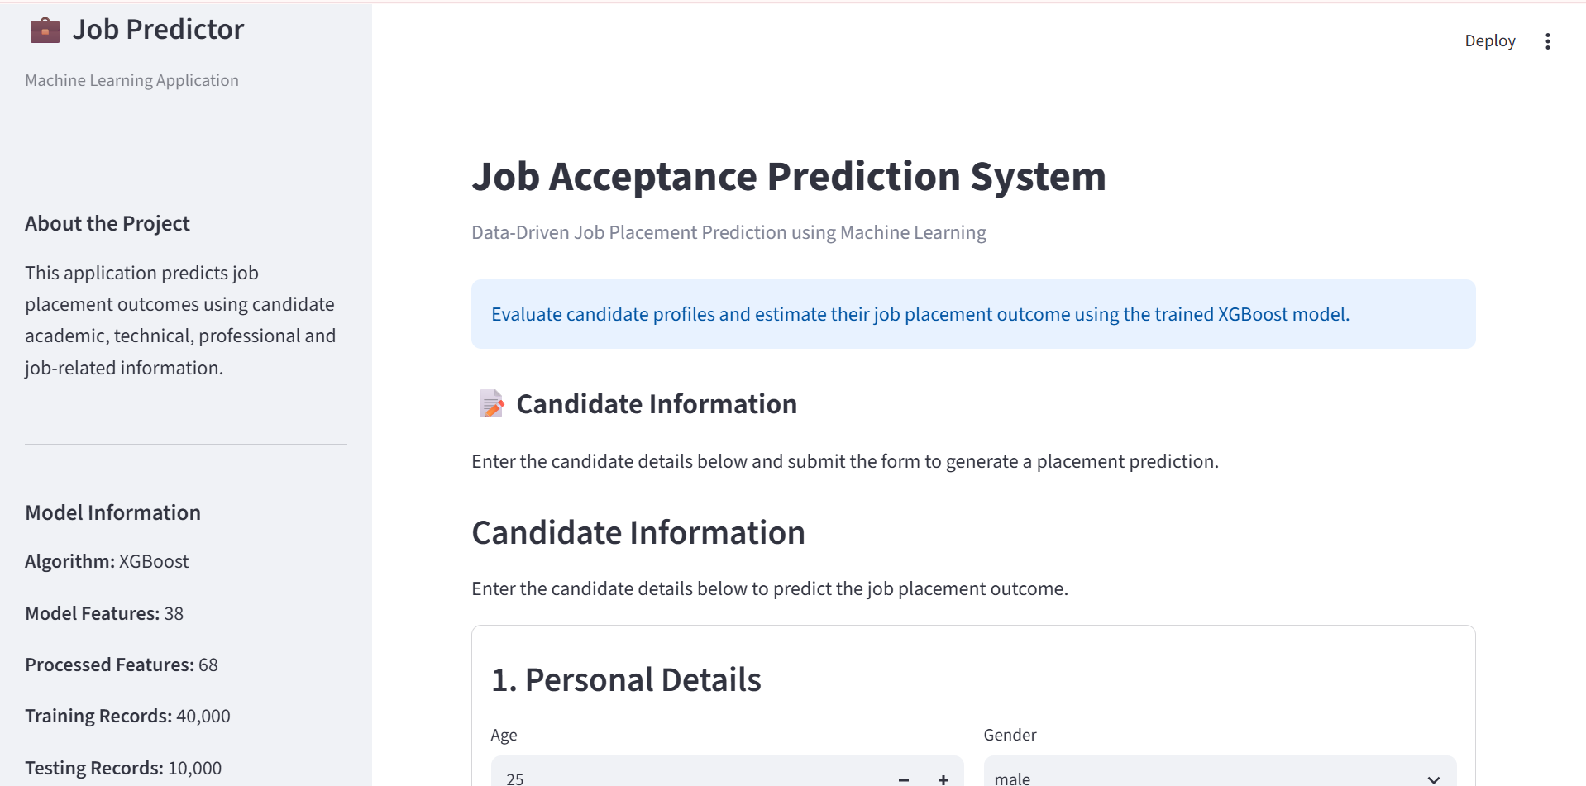
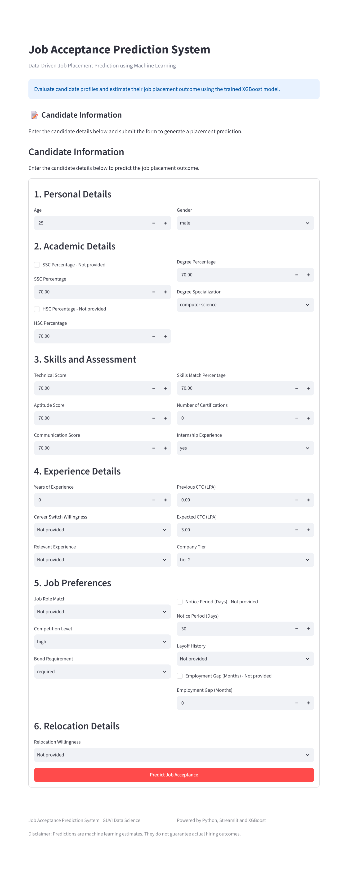

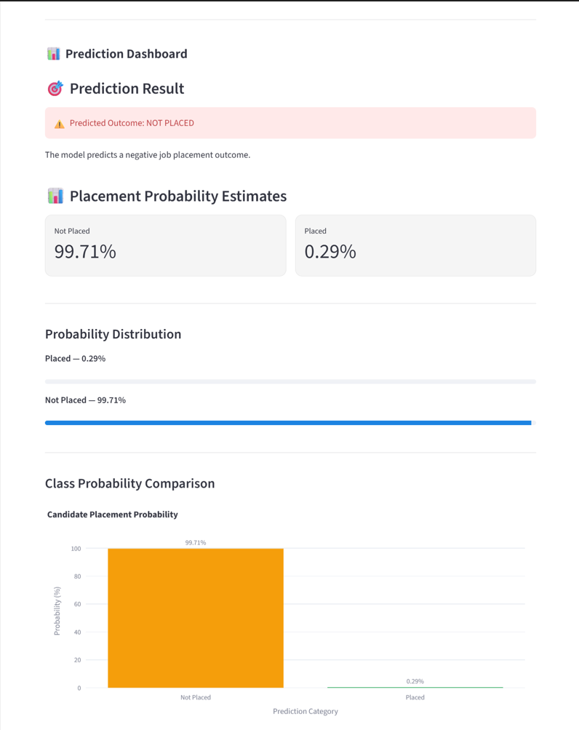

CHAPTER 10 – RESULTS AND BUSINESS INSIGHTS
10.1 Project Results
The project successfully completed the major stages of the machine learning workflow.
The final validated dataset contains:
- 50,000 records.
- 35 columns.
- No remaining missing values.
The final model uses:
- 38 input features.
- 68 processed features after preprocessing.
The final XGBoost classifier achieved:
- 91.79% accuracy.
- 86.93% precision.
- 85.76% recall.
- 86.34% F1-Score.
- 97.62% ROC-AUC.
10.2 Application Results
The Streamlit application successfully integrates the saved model and preprocessing pipeline.
It accepts new candidate details and displays a placement prediction along with class probability estimates.
A sample prediction test produced:
Output | Sample Result
Predicted status | Placed
Not Placed probability | 0.01%
Placed probability | 99.99%
Original input fields | 25
Model input features | 38
Processed features | 68

10.3 Business Interpretation
The system demonstrates how candidate data can be used to build a structured placement prediction workflow.
It can support HR teams by:
- Organizing candidate information.
- Supporting consistent candidate assessment.
- Identifying patterns associated with placement outcomes.
- Providing model-based placement estimates.
- Supporting recruitment analytics.
The system should be used as a decision-support tool rather than an automated hiring decision-maker.
10.4 Recommendations
- Use the prediction as one input among several recruitment evaluation factors.
- Review candidate qualifications and interview performance independently.
- Monitor model performance on new candidate data.
- Examine prediction errors before using the system in recruitment operations.
- Evaluate fairness and potential bias across relevant candidate groups.

CHAPTER 11 – LIMITATIONS AND FUTURE ENHANCEMENTS

11.1 Limitations
The project has the following limitations:
- The model depends on the quality and representativeness of the training dataset.
- Historical placement patterns may not represent future recruitment conditions.
- Model probability estimates are not necessarily calibrated probabilities of real-world placement.
- The model predicts placement status and does not directly establish whether an offer was accepted or rejected.
- The application has not been established as a production recruitment system.
- Further testing is required on independent candidate data.
11.2 Future Enhancements
The following improvements can be considered:
Model Explainability
Integrate SHAP to explain how candidate features influence individual predictions.
Probability Calibration
Apply probability calibration techniques to improve the reliability of probability estimates.
Database Integration
Integrate a database to store candidate details and prediction history.
Candidate Comparison
Allow users to compare multiple candidate profiles.
Model Monitoring
Monitor prediction performance using newly collected data.
Cloud Deployment
Deploy the Streamlit application to a cloud platform for wider accessibility.
Dashboard Enhancements
Add feature importance, model performance charts, and additional analytical visualizations.

CHAPTER 12 – CONCLUSION

The Job Acceptance Prediction System demonstrates the application of machine learning techniques to Human Resource Analytics.
The project covers the complete data science workflow, including data understanding, data cleaning, missing-value handling, duplicate removal, outlier analysis, exploratory data analysis, feature engineering, machine learning model development, evaluation, and application deployment.
The final XGBoost model achieved 91.79% accuracy and 97.62% ROC-AUC on the test dataset.
A modular Streamlit application was developed to collect candidate information and generate placement predictions using the saved machine learning model and preprocessing pipeline.
The project provides practical experience in developing an end-to-end machine learning application and demonstrates how data science can support structured, data-driven recruitment analysis.

APPENDIX A – PROJECT TECHNOLOGY STACK
Tool | Application
Python | Programming
Pandas | Data cleaning and analysis
NumPy | Numerical computation
Matplotlib | Data visualization
Seaborn | Statistical visualization
Scikit-learn | Preprocessing and evaluation
XGBoost | Final classification model
Plotly | Interactive charts
Streamlit | Web application
Joblib / Pickle | Model persistence

APPENDIX B – PROJECT FILE STRUCTURE
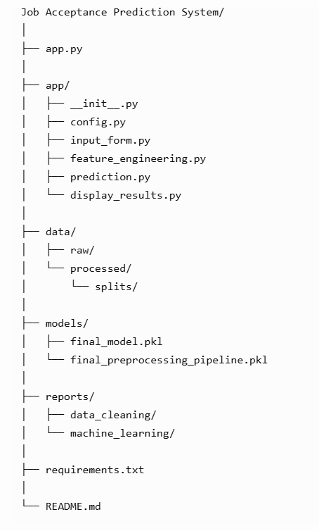

APPENDIX C – FINAL PROJECT SUMMARY

Component | Final Result
Project | Job Acceptance Prediction System
Domain | HR Analytics
Original dataset | 51,500 rows × 26 columns
Duplicates removed | 1,376
Final validated dataset | 50,000 rows
Final cleaned columns | 35
Model input features | 38
Processed features | 68
Training records | 40,000
Testing records | 10,000
Final algorithm | XGBoost
Accuracy | 91.79%
Precision | 86.93%
Recall | 85.76%
F1-Score | 86.34%
ROC-AUC | 97.62%
Deployment | Streamlit

End of Project Report

